History of Fire Towers in Mohican State Park
Questions have existed for some time about location of wood the fire tower in Mohican State Park. The following article from 1936 discusses protecting the park from fire hazards and says an 86-foot steel tower was erected on the south side of the park and a 45-foot wood tower was erected on the north side. 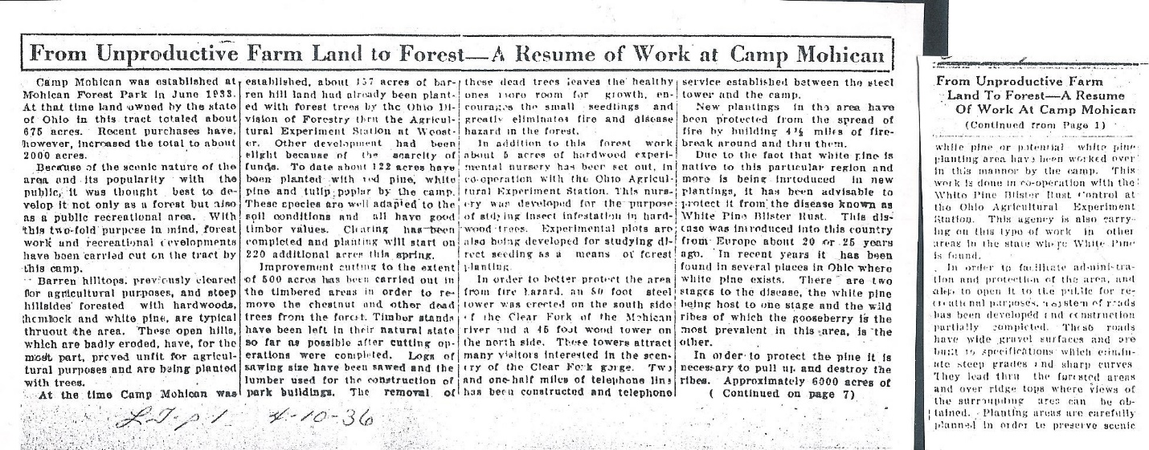
The steel tower still exists today and a rehab is planned for the summer of 2021. However, the wood tower has long been missing and the only known picture of it is in one of the many hand drawings made by Joe Jesensky when he was the park chief architect in the 1930’s. The tower is in the bottom left-hand corner. Notice in the legend on this drawing that a circle with a dot in the middle identifies the location of both towers, including the one on the north side.
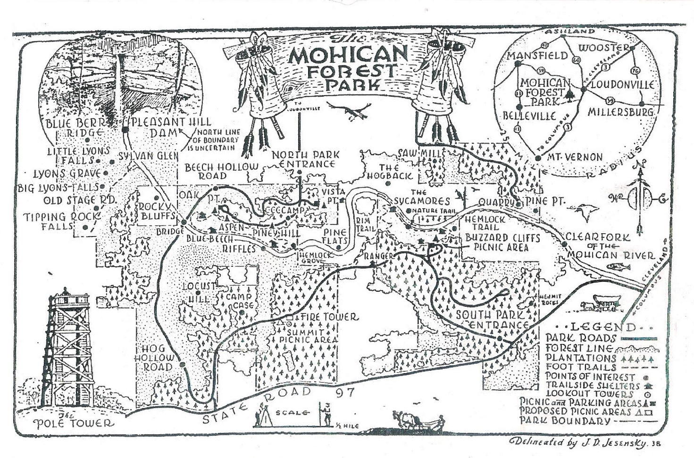

Two other park maps show the location of the pole tower:
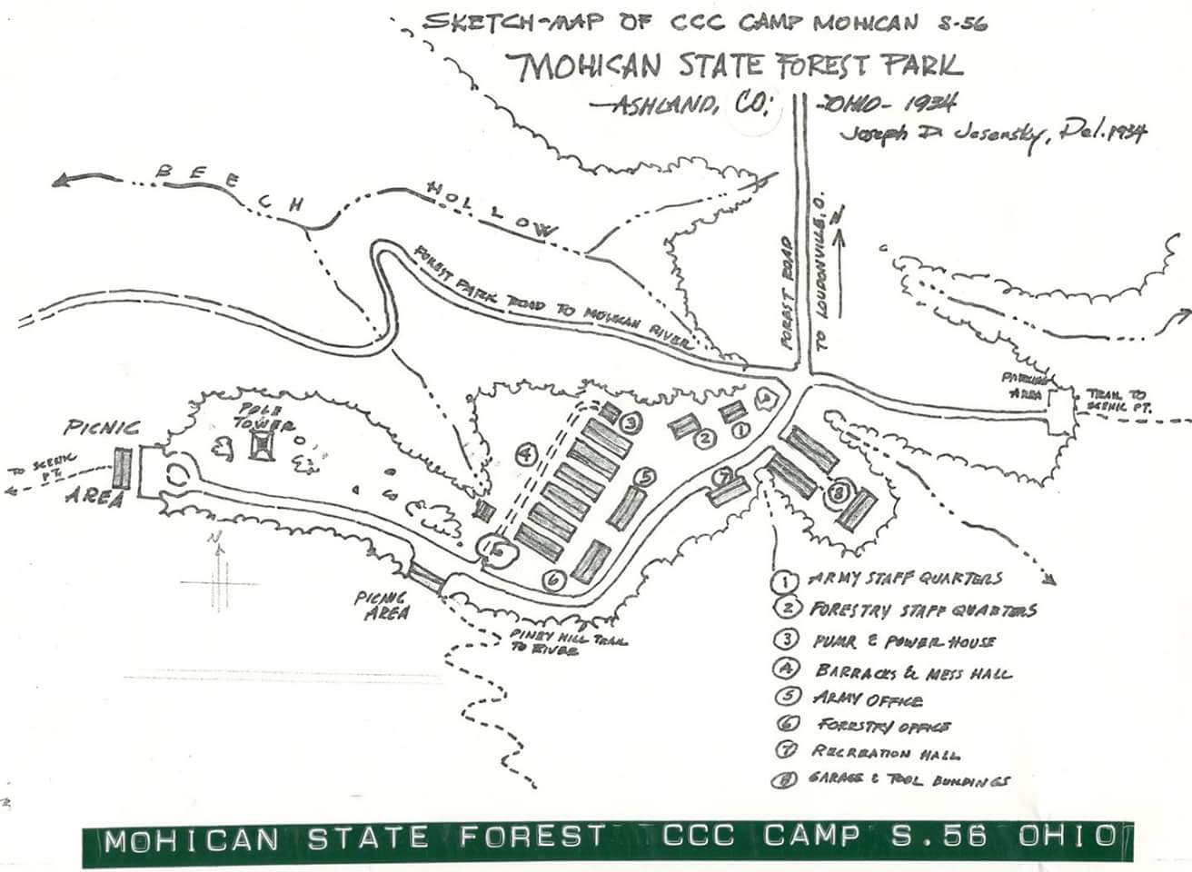
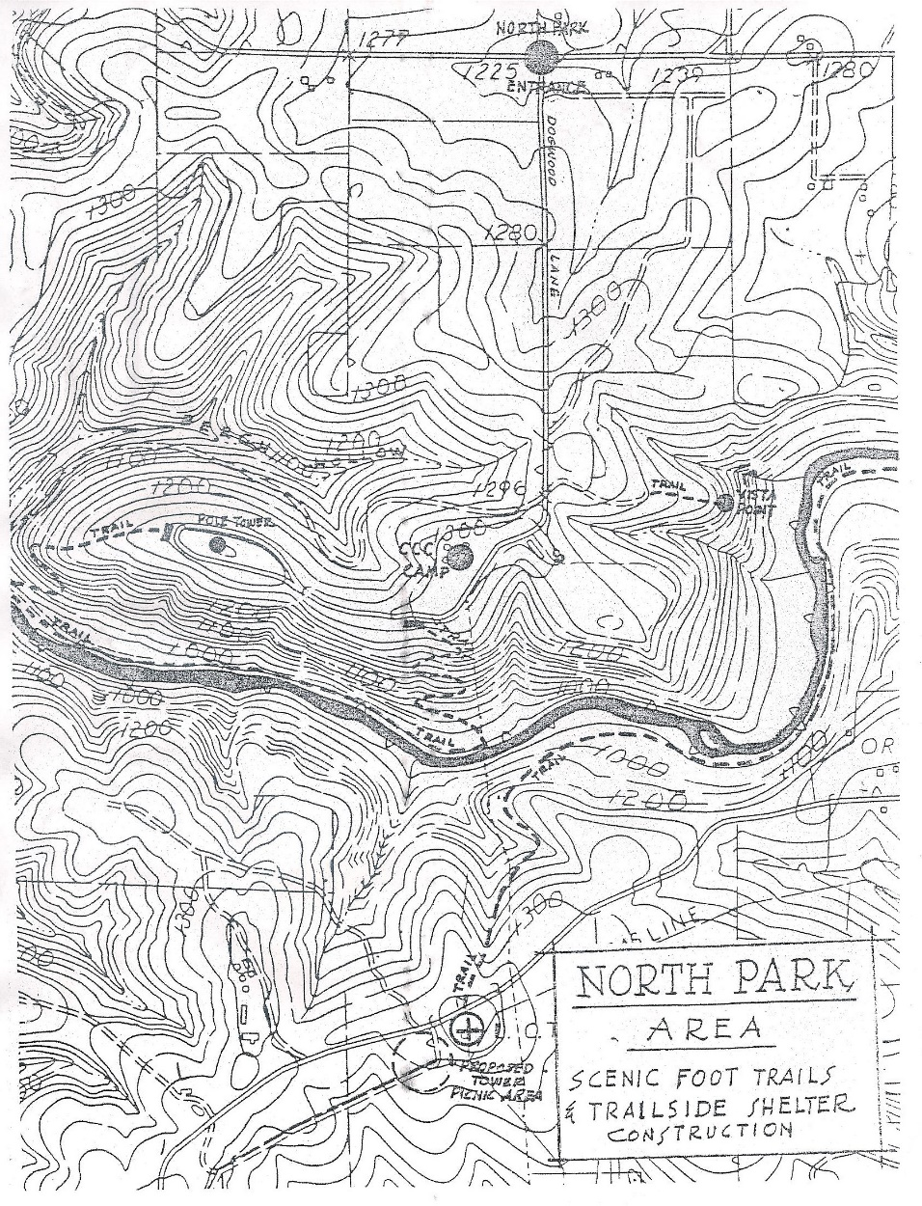
The two Jesensky drawn maps have the road to the large shelter house drawn differently from how it is today and on these two maps the pole tower is on the west side of the road leading to the large shelter. The latter topo map has the tower inside the one-way roads. The topo map is the first map I have found where Jesensky uses a map that apparently was prepared by surveyors and includes contour lines and accurate roads. It appears Joe then added proposed trails and a location for the “proposed” steel fire tower in the south park. The proposed steel fire tower site was apparently moved as was the nature trail. Joe told us the reason the nature trail was moved - it was on private property (assuming the Stevenson property).
The point here is that these maps were used for planning purposes and the final location of the park’s features could have been different from this plan. The location of the pole tower inside the one-way roads may have been changed before the tower was constructed because of gas wells.
Around 1915 gas wells became unproductive in this area and were being converted to storage wells. The pole tower site inside of the one-way roads has had a storage well head for as long as I can remember. This may have prohibited the construction of a tower there.
As we have said before, a tower of this size would require a foundation and no foundation could be located inside the one-way roads. The storage well head was removed this summer and during this process no foundations could be located. The foundation on the ridge behind the small shelter house is the most likely place for to have been built. From this ridge there is an excellent view of the river gorge There are four distinct concrete blocks. Perhaps next spring we could do a little excavation to see if there is more evidence.
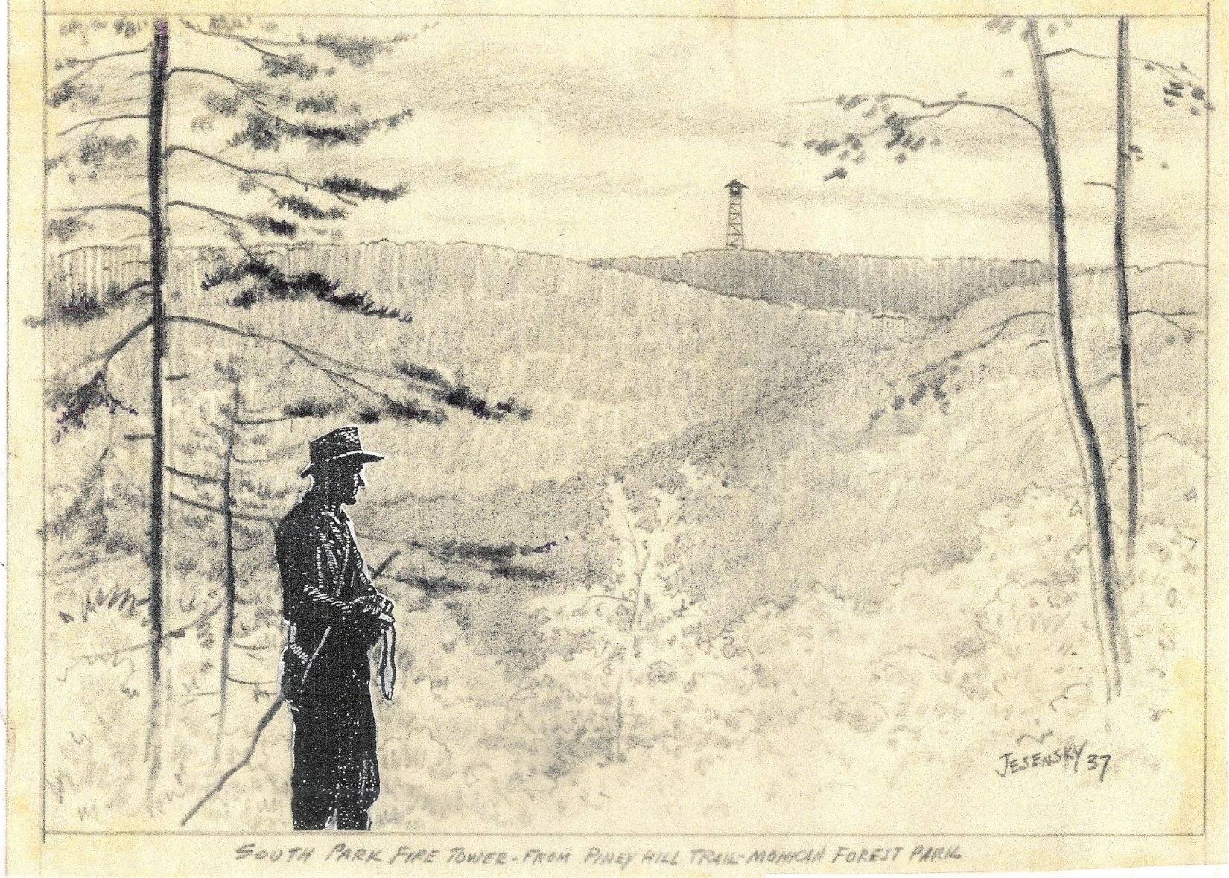
There are a couple of reasons this could be wrong. One is that this picture of Joe standing at about where we believe the pole tower was located make no mention of it. In addition, the steel tower has a good view of the gorge and a tower at this location may be redundant. A tower is needed west of this location to look to the west from the other side of this ridge. Since the first two maps show the pole tower on the west side of the road to the large shelter house this must also be explored to locate a foundation. Another project for next spring.

